**MongoDB Day 1**

**1.** **Find all the information about each product**

db.product.find({})

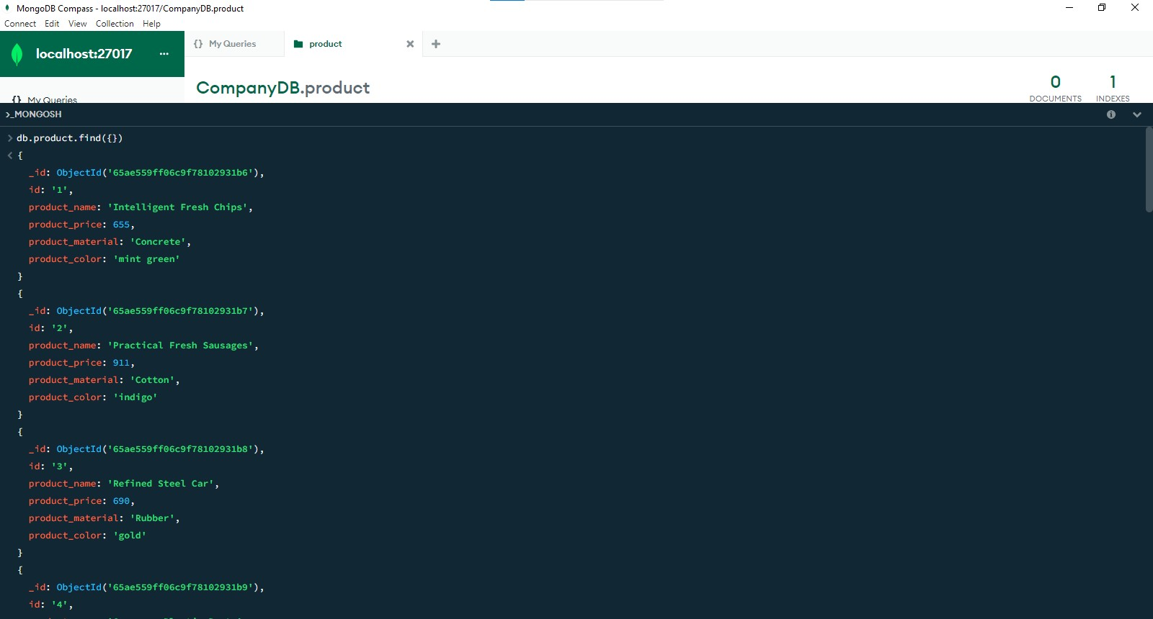

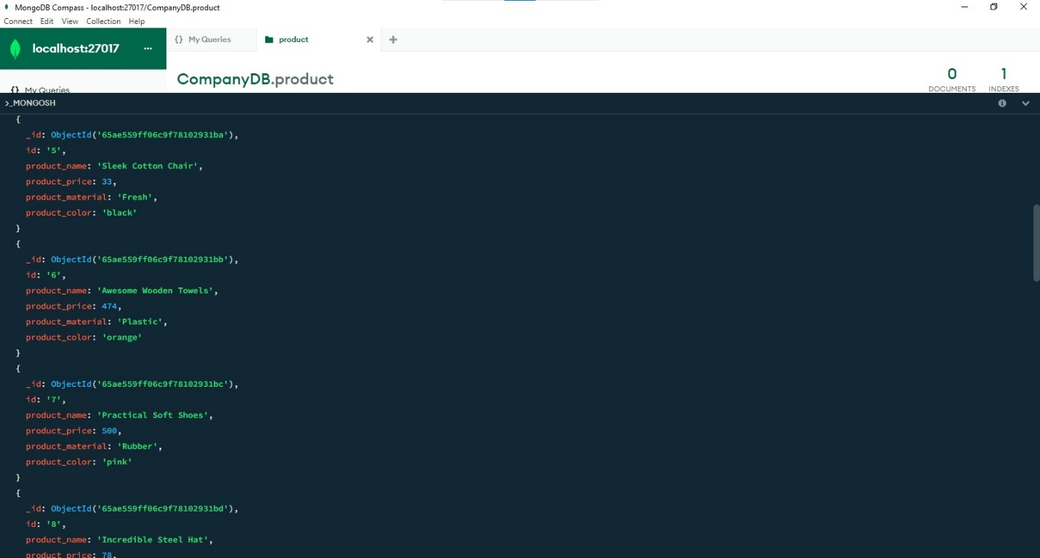

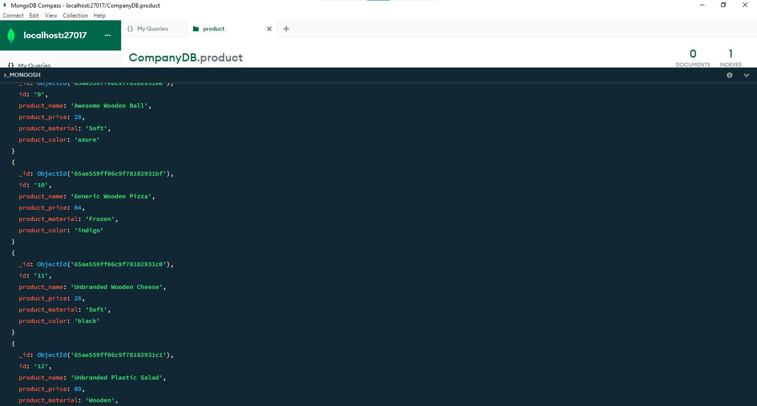

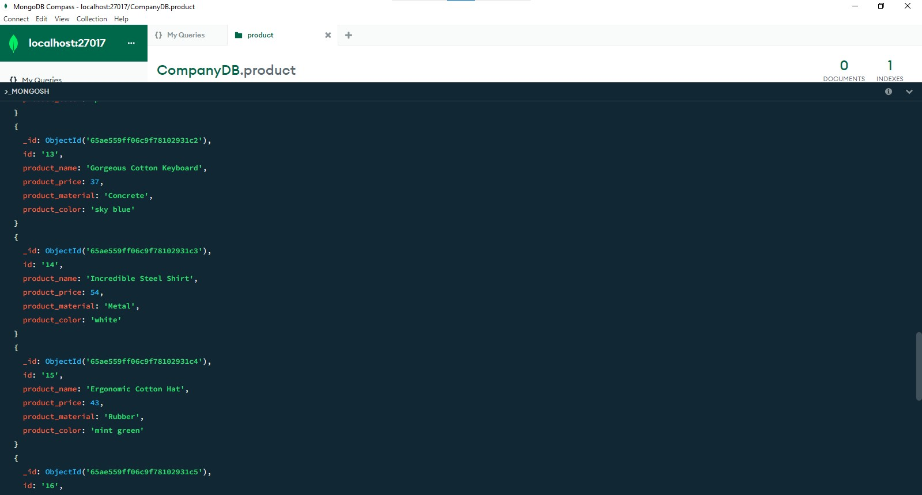

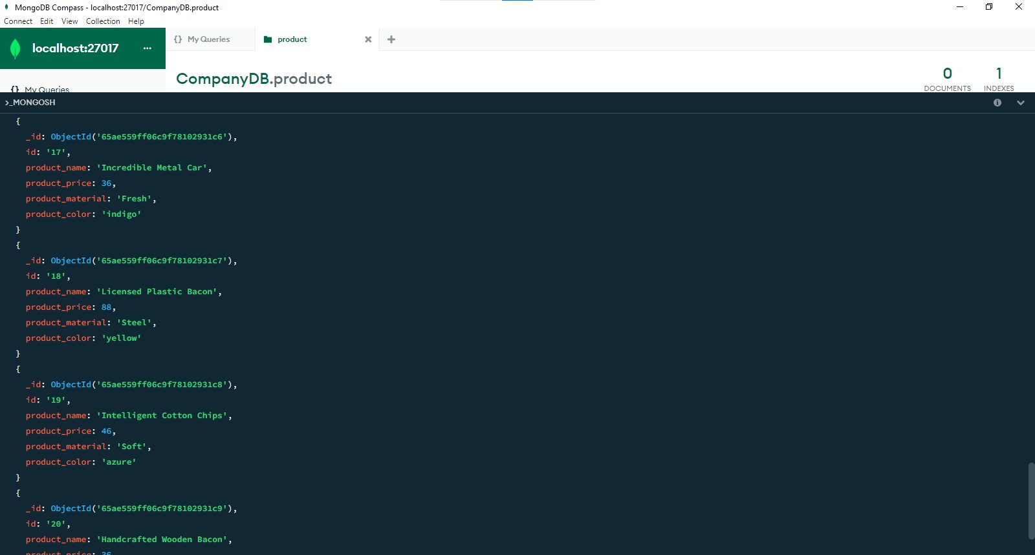

2. Find the product product_price which are between 400 to 800

db.product.find({ product_price: { $gte: 400, $lte: 800 } })

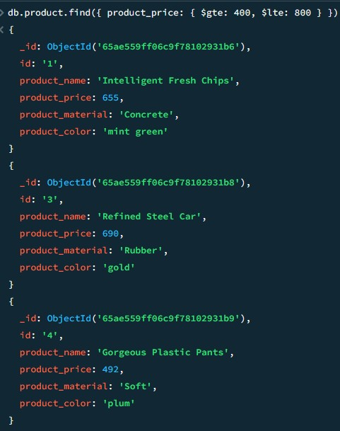

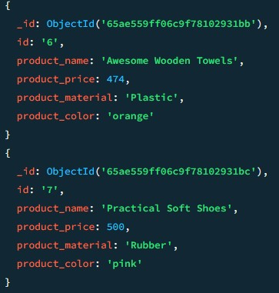

3. Find the product product_price which are not between 400 to 600

db.product.find({ product_price: { $not: { $gte: 400, $lte: 600 } } })

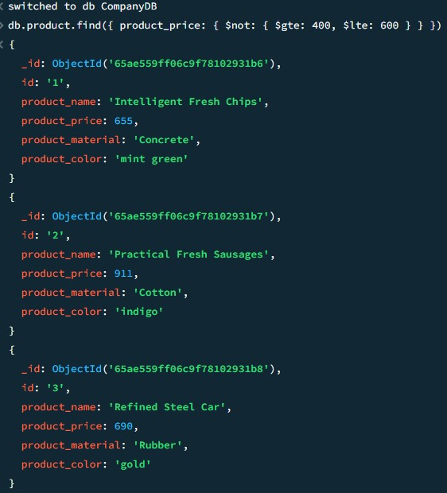

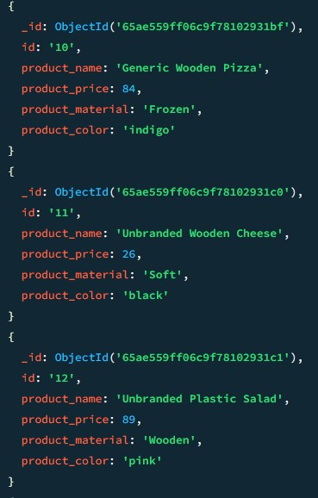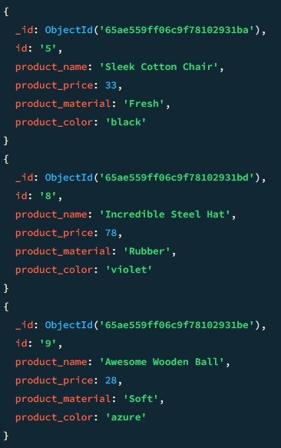

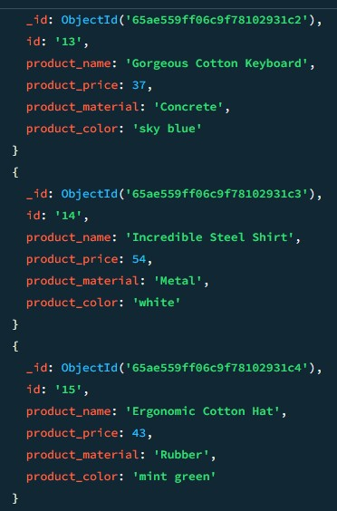

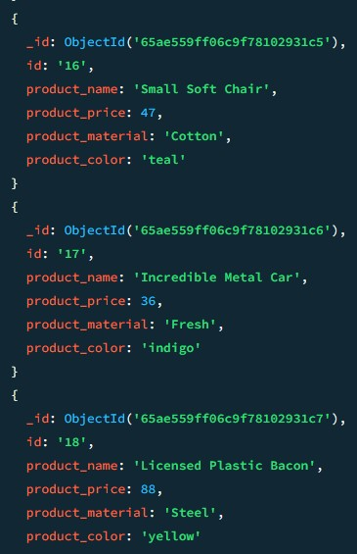

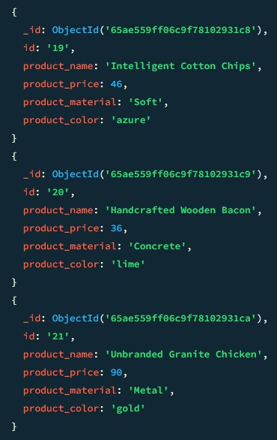

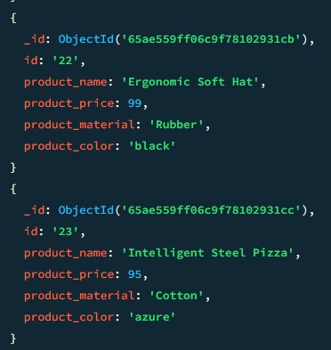

4.List the four product which are grater than 500 in product price

db.product.find({ product price: { $gt: 500 } }).limit(4)

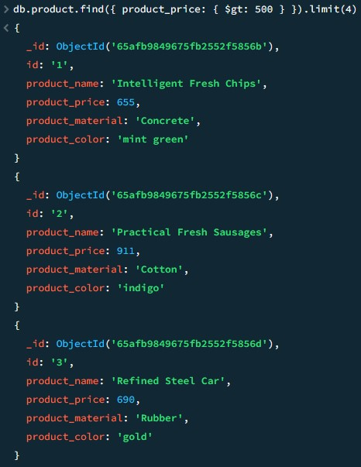

5 Find the product name and product material of each product

db.product.find({}, { product_name: 1,product_material: 1, _id: "0" })

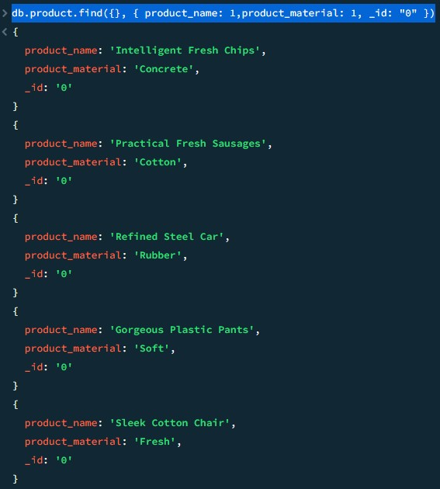

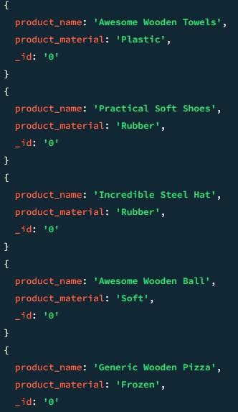

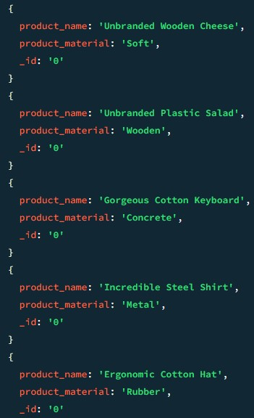

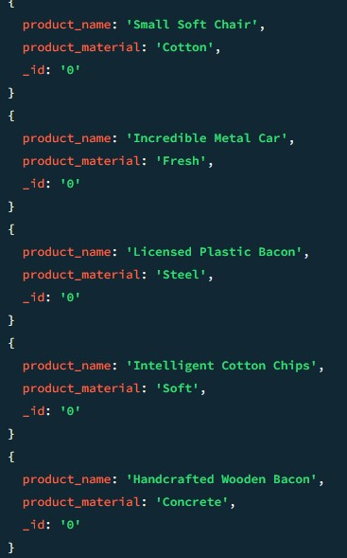

6.Find the product with a row id of 10

db.product.findOne({ id: "10" })

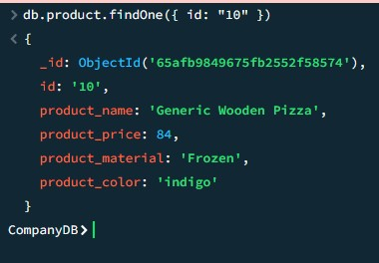

7.Find only the product name and product material

db.product.find({}, { product_name: 1, product_material: 1, _id: "0" })





8. Find all product which contain the value of soft in product material

db.product.find({ product_material: /soft/i })

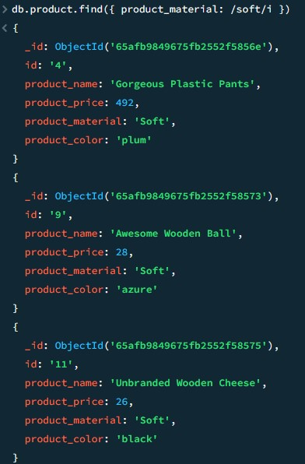

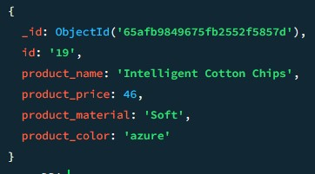

9.Find product which contain product color indigo and product product price 492.00

db.product.find({ color: "indigo", product price:36 })

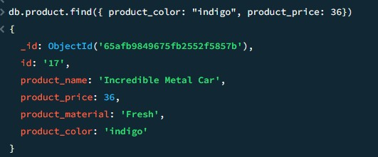

10 Delete the product which product product price value are same

db.product.deleteMany({ product price: { $eq: 492.00 } })

